Now what we are going to do is we are going to assets folder in project panel and then to script folder. Inside the script folder and then create a few script there that we are going to use in this case
Now we will open Script folder inside project panel by double clicking on the script folder shown in Project mini tab
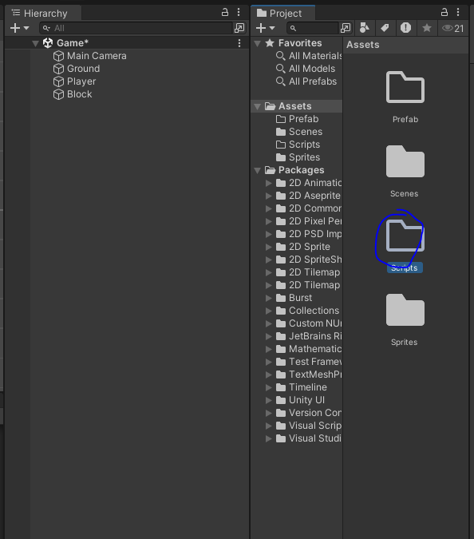
And now right click on minipanel inside project panel and then a submenu open and then go to create button and then another submenu will be opened click on C# Script button as shown below
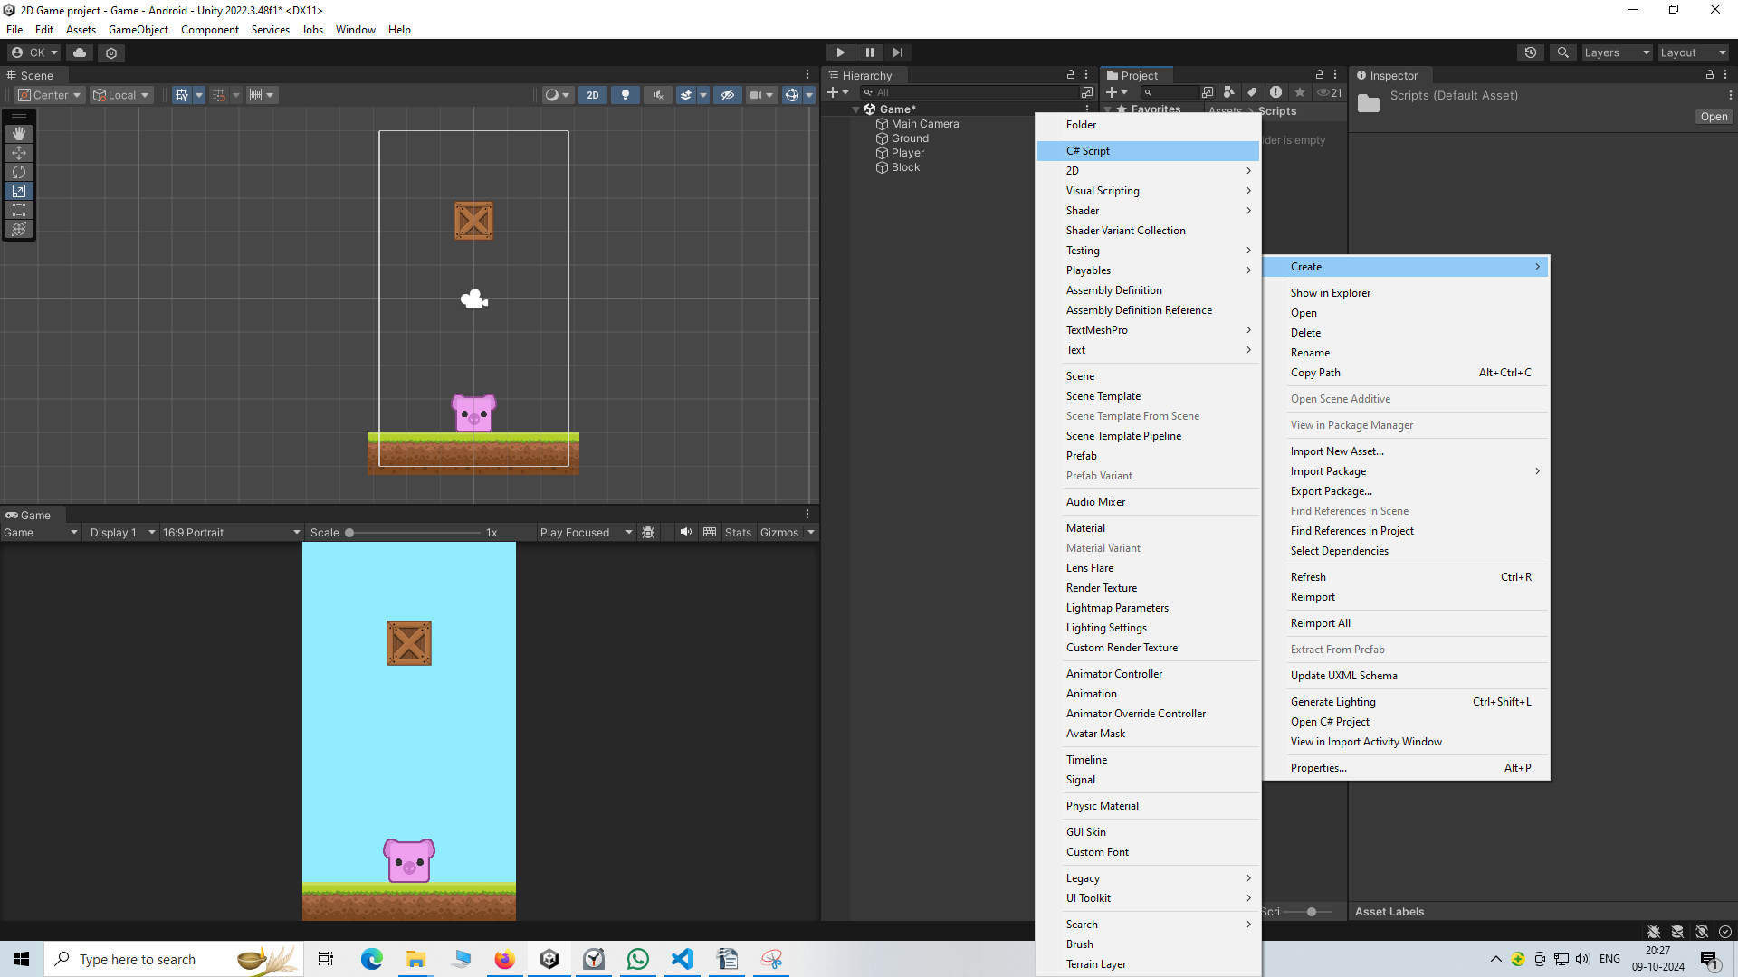
Now we will create a script folder inside assets folder named Player

Then we are going to create another script file that is We will name this script as game manager then create another C# script that is Block
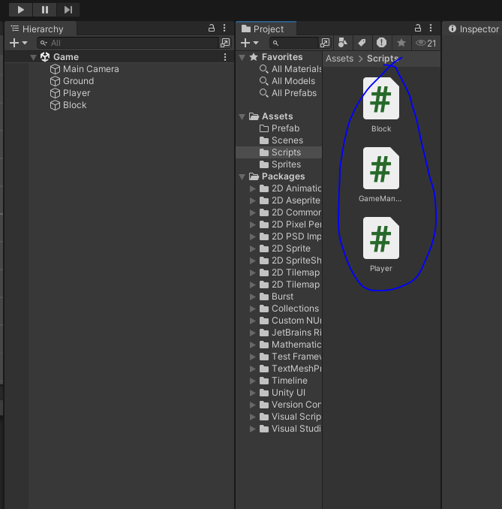
So we are now going to select the block assets inside the Heirarchy panel and now we are going to inspector pabel and drag and drop the Block script on the empty area of Inspector panel or on add component button
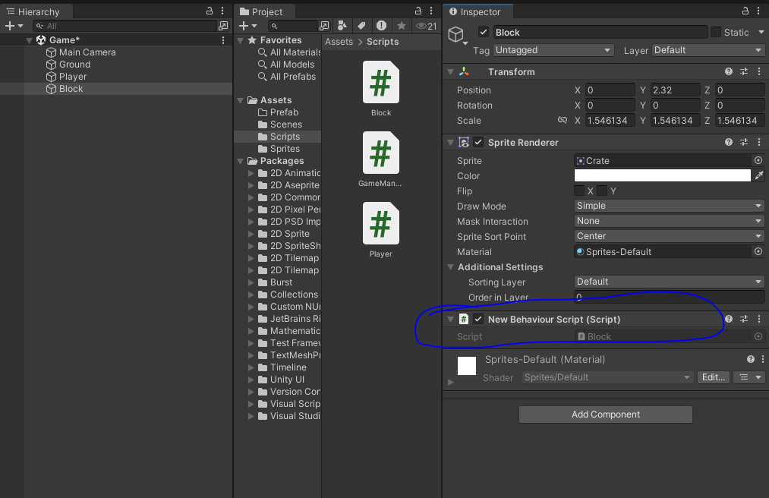
Now in Inspector panel of block asset you can see the block script component added as marked above or you can also add script to the assets by clicking on the Add Component button and then a submenu will be opened
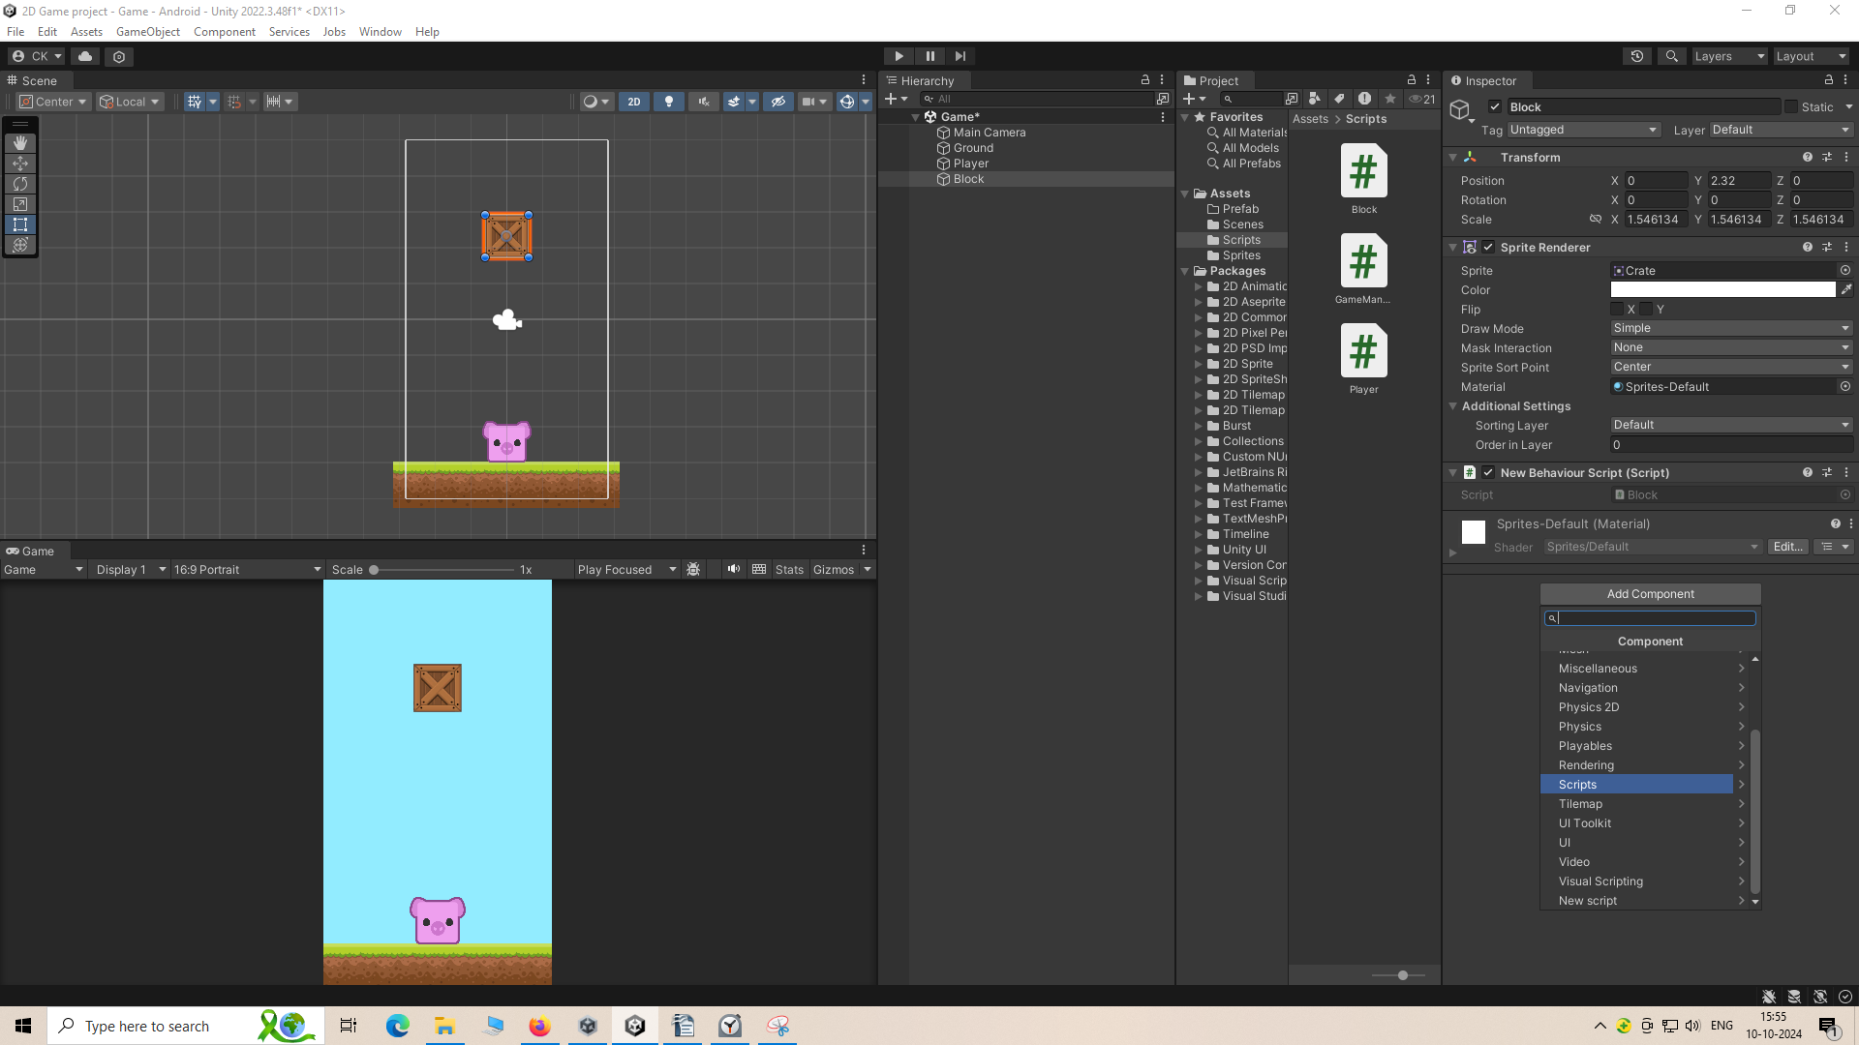
Go to screen option and then the submenu will be updated
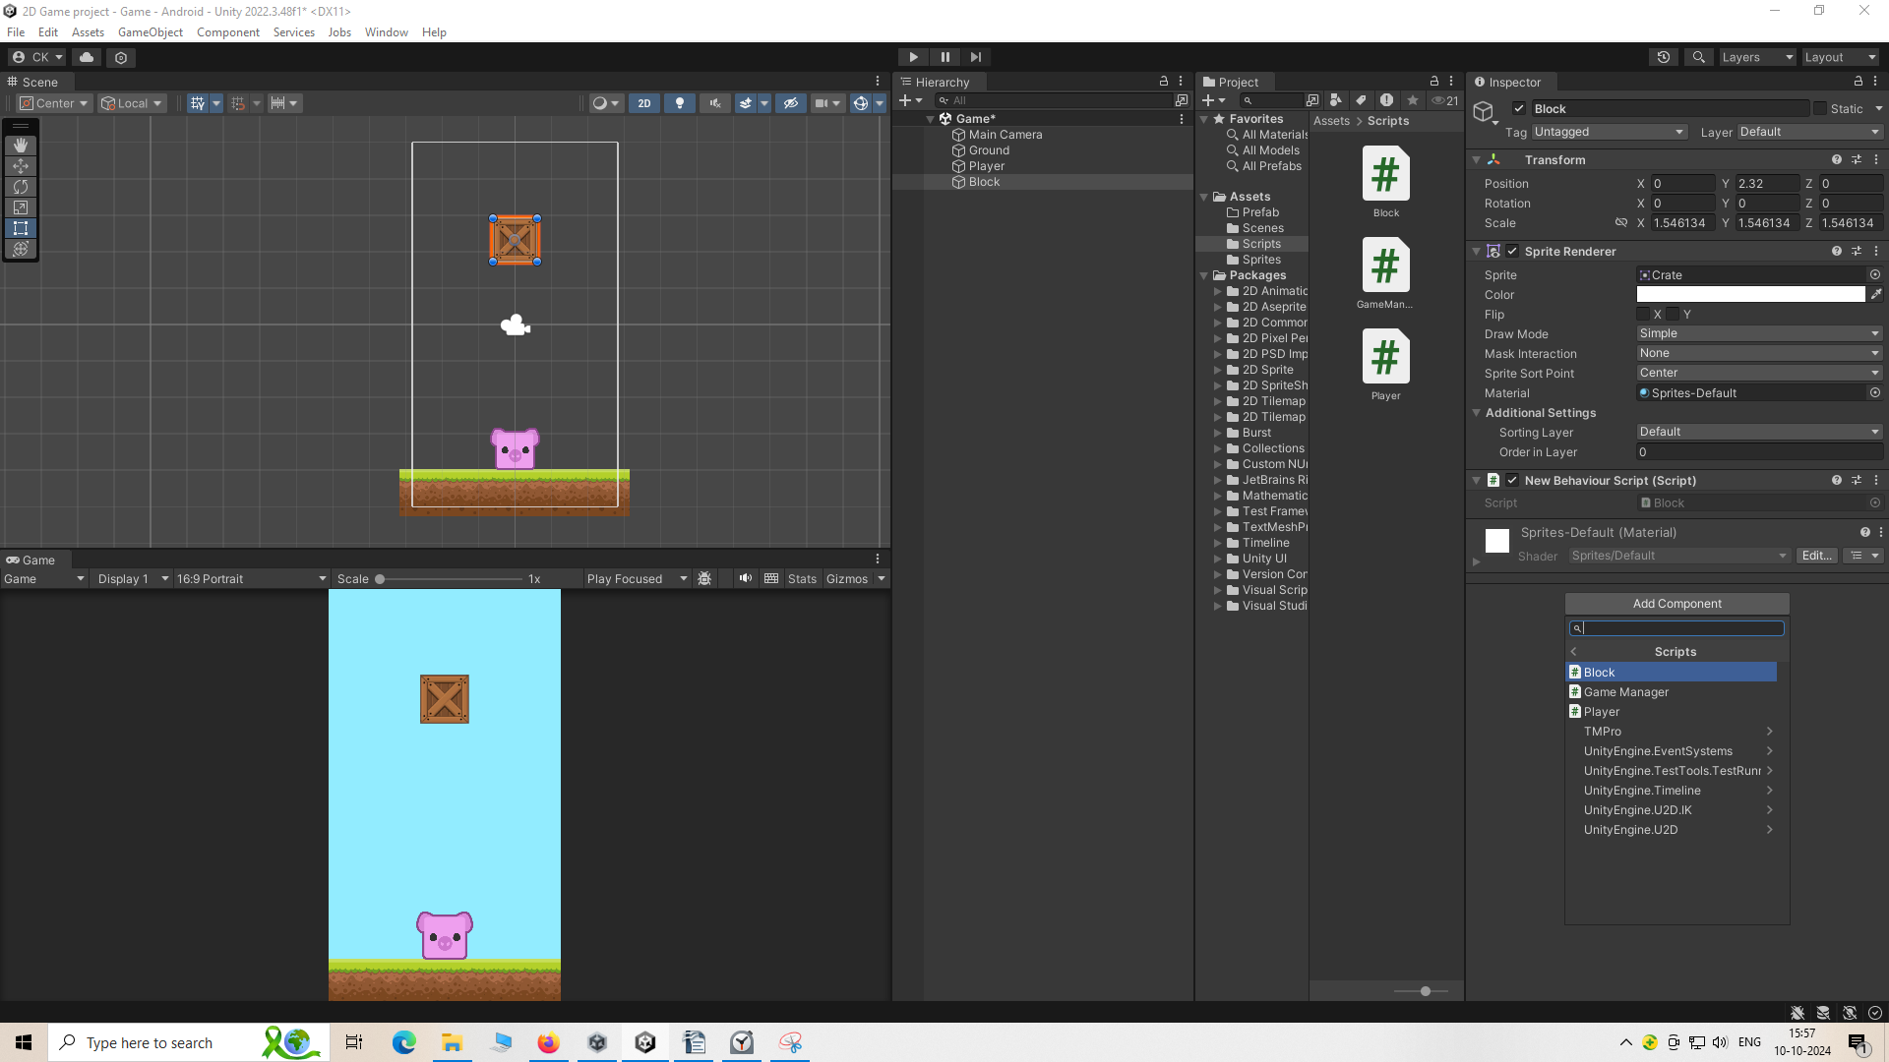
Now go to Block script option
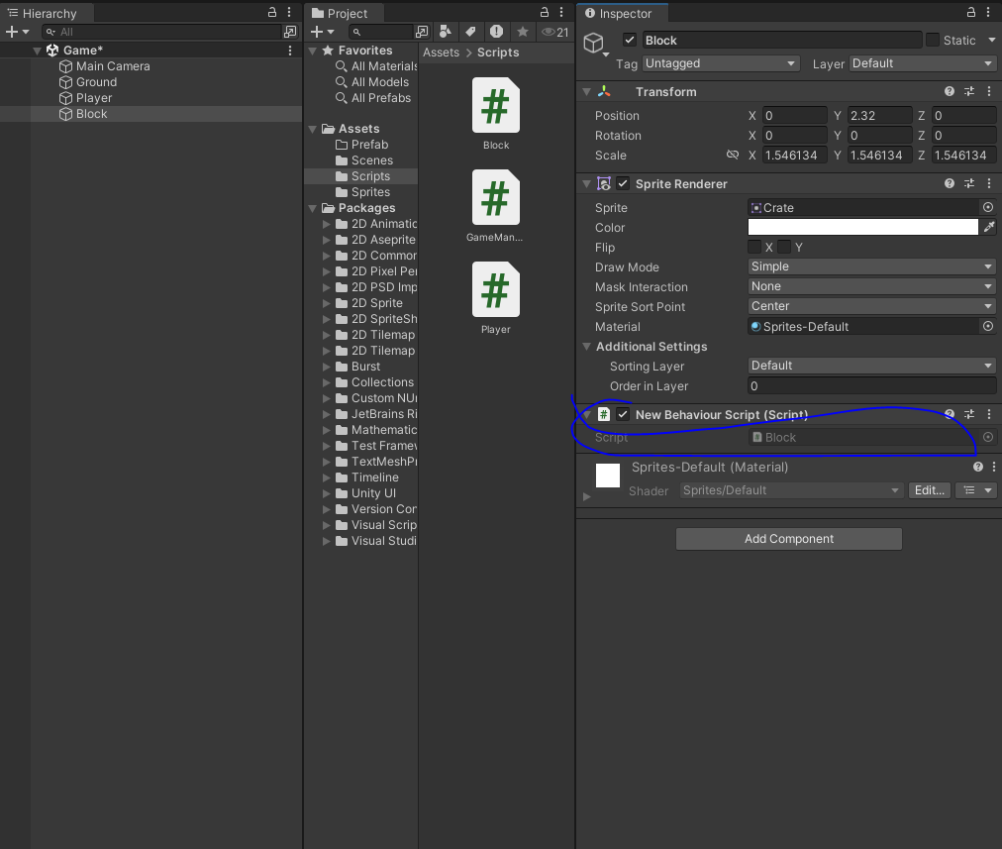
Now you can see above the the script component is added as marked above
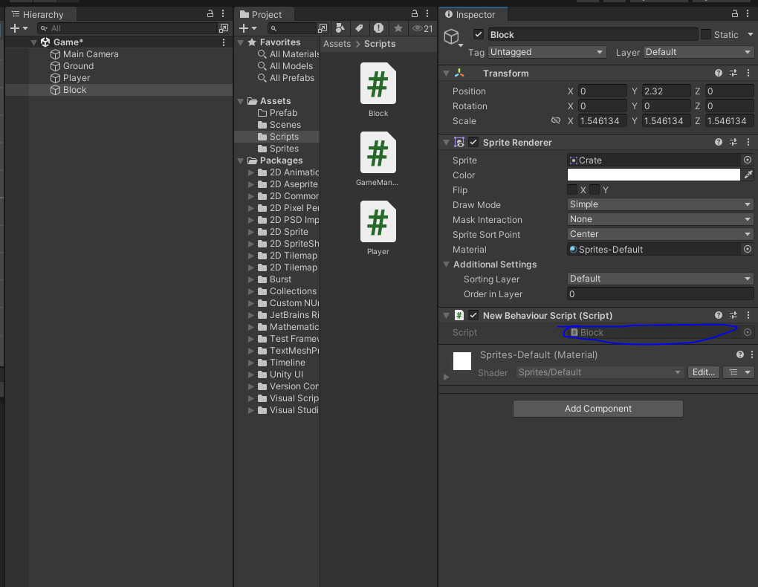
Now double the marked above to open our Visual Studio like below
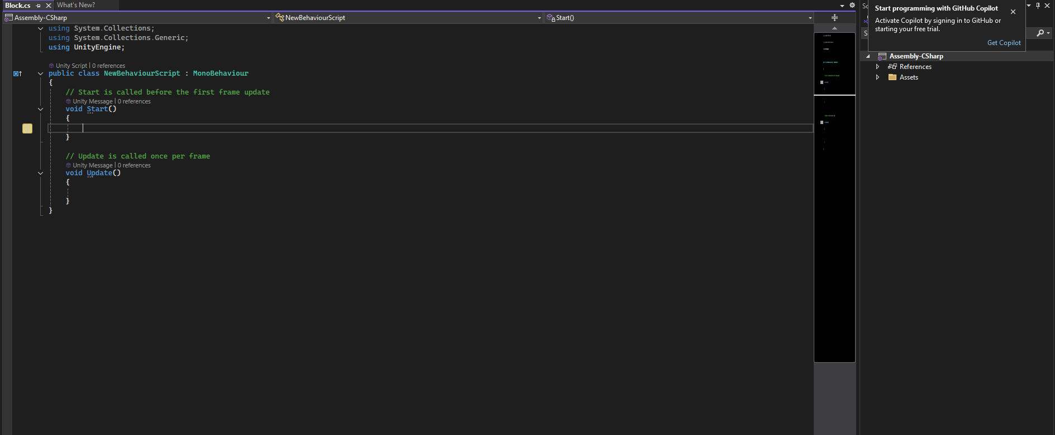
In above screen we can arite our first code
Since we dont't need this start method we will remove it now it will look like this
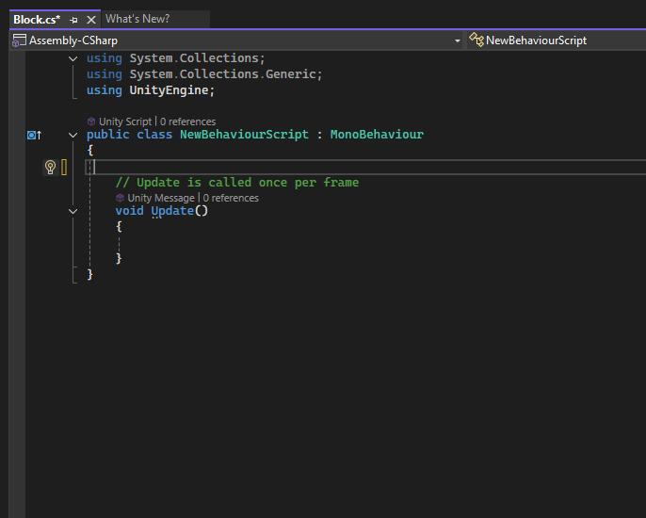
So what are we gonna do is that we first check if block is outside of the screen then we will delete it
therwise there will be so many boxes clustered on the screen
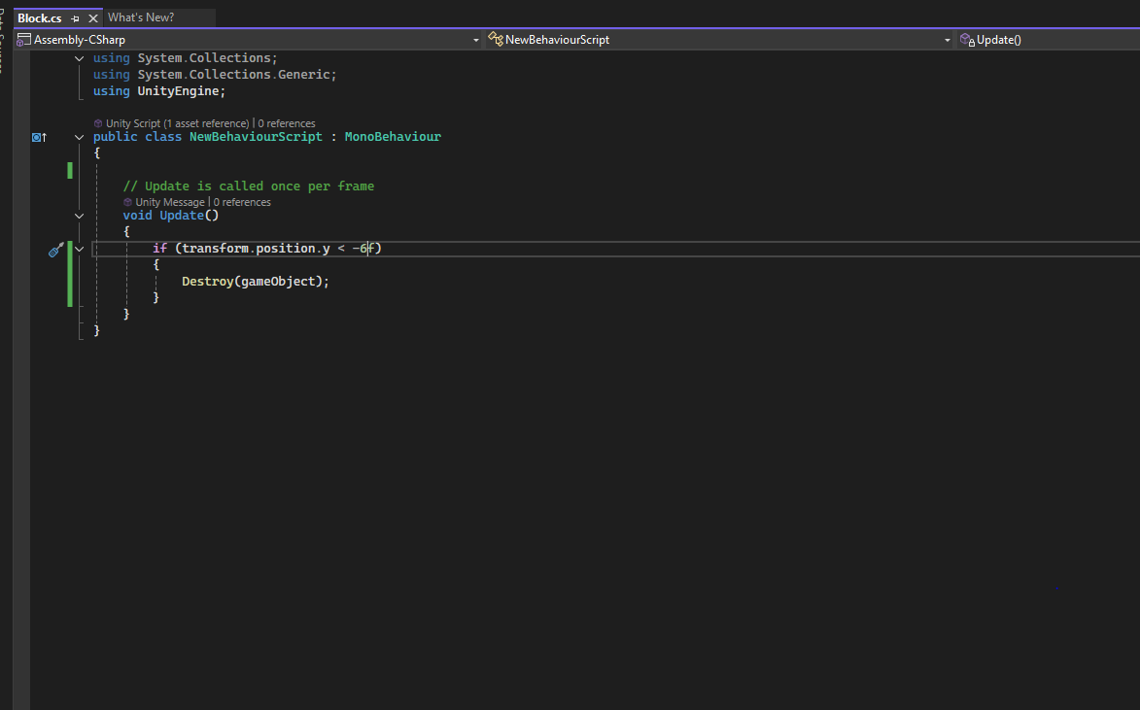
In above code -6f is below our camaera level as the origin is in center of the screen
So in our code
we have update method which may b called in repeatedly after every frame(means millisecond)
and start method that we removed in our code may be used when the asset is created at runtime.
Now in our code there is a transform object maybe this is provided by the framework(Unity) or by Parent class MonoBehaviour
and may be Destroy is a method provided by the framework or by MonoBehavior parent class
This method is actually Destroy a sprite(assets) and since it is taking the gameObject object(I think the gameobject is the object which is actully the asset reference to which our script is attached to) I think we get it by frame work or by MonoBehaviour
Now we are going to move ahead and make it a Prefab.
A Prefab is a sprite(assets) which we can reuse again and again(which actually means generating the assets at runtime dynamically)
And here we are going to use this box as our obstacle again and again. And that is why we need to set it as a prefab
So we are going to drag and drop our block from our Heirarchy Panel and to the prefab folder in Project's mini panel(If it shows insides of prefab folder). Or insise the project panel on the prefab folder
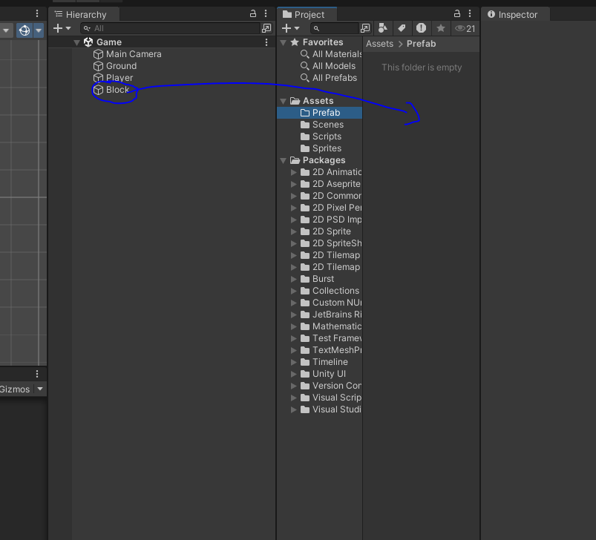
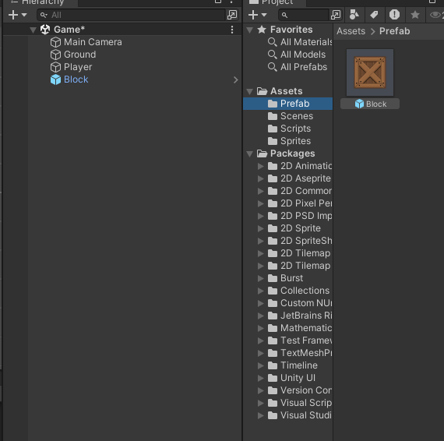
In above you can see Block asset as blue in color means it is now prefab as shown above
Now we will disable the block present in heirarchy panel or scene panel as it is not needed anymore as it is already present in prefab and will not be shown in the screen so first we will select the block in the screen or heirarchy panel
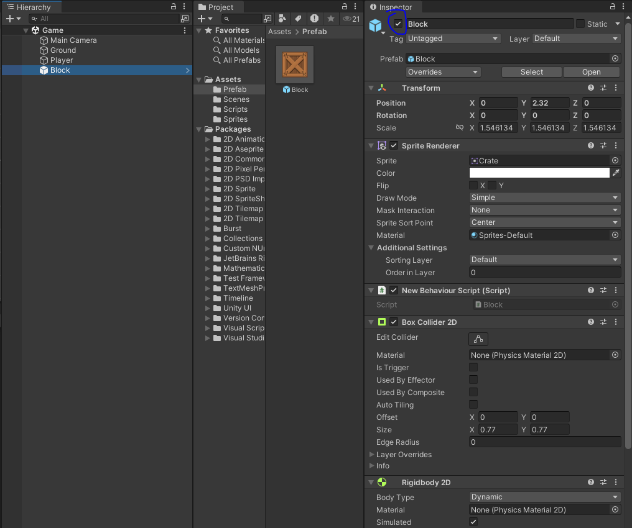
and then we will go to Inspector panel and uncheck the above marked checkbox
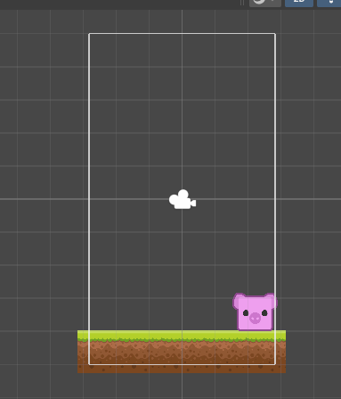
Now you can see that in scene panel that the block is not visible.

